Use of Excel to Calculate Complicated Transfer Functions

Students may initially be daunted when asked to use Excel to generate and plot the magnitude and phase data in Excel. However, a few simple tricks can greatly simplify the process. Consider the transfer function of Equation 1.

|  |  |  |
| --- | --- | --- |
|  | $$H\left(jω\right)=42\frac{jω+100}{\left(jω+20\right)\left(jω+800\right)}$$ | Equation 1 |

To obtain the magnitude and phase, first break the expression into three parts, the first being $jω+100$ in the numerator, the second being $jω+20$ in the denominator, and the third being $jω+800$ in the denominator. To obtain the magnitude, divide the magnitude of the numerator but the product of the magnitudes of each term in the denominator.[1]

|  |  |  |
| --- | --- | --- |
|  |  | Equation 2 |

Similarly, break Equation 1 into the same terms to calculate the phase.[2]

The angle of each term is the arctangent of the imaginary part divided by the real part. Since the imaginary part of 42 is zero, $∠42=0$, so any real coefficients are irrelevant to the phase calculation.

|  |  |  |
| --- | --- | --- |
|  | $$∠H\left(jω\right)=\arctan\left(\frac{ω}{100}\right)-\arctan\left(\frac{ω}{20}\right)-\arctan\left(\frac{ω}{800}\right)$$ | Equation 3 |

You now want to create a frequency axis. Assume that the bode plot needs to span from 0.1 Hz to 100 kHz. You would like the frequency values to be logarithmically spaced from one another. Spacing them linearly would cause you to have only a few frequencies in the lower decades and a ridiculously large number of frequencies in the higher decades. I.e. if you decide to space the frequencies 0.01 Hz from one another, then you would end up with about 1 million points between 10 kHz and 100 kHz. Therefore, generate each frequency so that it is some factor larger than the previous value. If you choose 1.2 as that factor, then the first few frequencies will be approximately 0.1, 0.12, 0.144, 0.173, 0.207, 0.248, 0.299 Hz. In Excel, the axis is set up as shown in Figure 1.

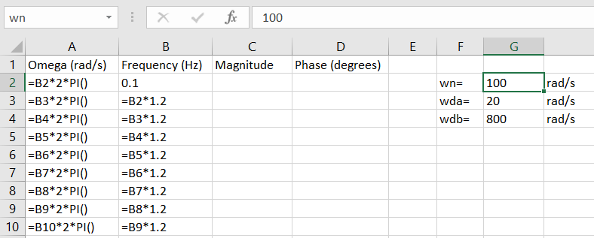

Figure 1: Frequency axis for the transfer function calculation.

Figure 1 shows three additional labeled columns besides the frequency in Hz. Column A is the frequency $ω$ in radians/s, which is convenient because the transfer function equation is written in terms of $ω$. Column C is where the magnitude will be calculated, and Column D is where the phase will be calculated. We *could* now use Equations 2 and 3 directly to calculate the magnitude and phase. However, for additional flexibility, the cutoff frequencies 100, 20, and 800 can be defined as variables so that, if one or more of these values changes, we will need to change only their defined values, as opposed to making changes to the equation. The practice also improves the readability of the worksheet.

Find a location on the worksheet that is not being used (and that you otherwise do not anticipate using in the future) and type in the information shown in the range $F2:$G4. Column G has the values that are to be defined. To define the value in cell $G$2 as “wn,” first click on the cell, then click on the window above Row A and type wn. Next click on cell $G$3 and type wda in the window above Column A. Do the same for Cell $G$4, naming it wdb.[3]

Now the equations can be easily calculated, as shown in .

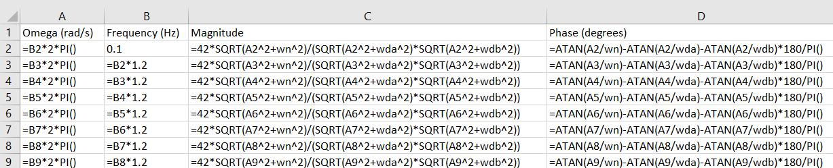

Figure 2: Formulas for the magnitude and phase calculations.

The resulting Bode plot is shown in Figure 3.

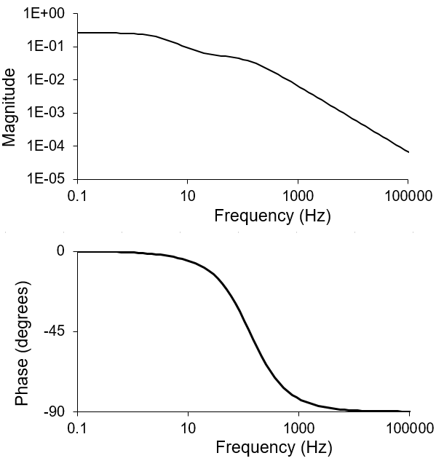

Figure 3: Excel-generated Bode plot

1. More generally, it can easily be shown that
2. More generally for phases, $∠\left(\frac{N_{1}N_{2}⋯N_{n}}{D_{1}D_{2}⋯D_{m}}\right)=∠N_{1}+∠N_{2}+⋯+∠N_{n}-∠D_{1}-∠D_{2}-⋯-∠D_{m}$, where $∠$ is read as “the phase of.”
3. These variable names are chosen to be mnemonic. The variable name wn stands for “the omega in the numerator.” Likewise, wda and wdb are “numerator omega a” and “numerator omega b.” Note that you cannot use names like w1 and w2 because Excel interprets them as cell addresses (e.g., Column W, Row 2).